Physics 20

Lesson 26 Energy, Work and Power

Let us recap what we have learned in Physics 20 so far. At the beginning of the course we learned about kinematics which is the description of how objects move in terms of acceleration, velocity, displacement and time. We also learned about vector quantities and how they added together to yield a resultant or net vector quantity. Next we learned how Newton’s three laws of motion and his universal gravitational law were tremendously successful in understanding the motion of objects including planets orbiting the sun. Newton’s ideas were so successful that people tried to use them in all situations. For example, people attempted to apply Newton’s ideas to the properties of gases. In terms of the relationship between forces, areas and pressures Newton’s ideas could be applied with great success. However, when his ideas were applied to understanding how heat was transferred from one gas to another, they were less successful. However, another way of thinking about physical phenomena was being developed particularly in relation to the study of thermodynamics (the study of heat) and the kinetics of gasses. This was the idea of **energy**.

For the next three lessons we will explore and develop the principles involving the idea of energy. As we shall see, many problems that are quite difficult to solve using kinematics and dynamics as the problem-solving tool are relatively easy to solve when we use energy principles.

(For this lesson, refer to pages 292 to 305 and 324 to 330 in Pearson.)

# Energy and its forms

The idea of Energy is one of the most fundamental principles in all of science. Everything in the universe is a manifestation or form of Energy. Energy is the fundamental or basic "stuff" of the universe. All physical processes can be understood as the **transformation** of one type or kind of energy into another.

**Chemical** chemical energy exists within the bonds that hold atoms together

**Radiant** various forms of light energy

radio / TV / microwaves / infrared (heat) / visible light / ultra violet / x-ray / gamma ray

**Electromagnetic**

electric potential energy (battery)

electric current

**Atomic** binding energy within the nucleus

**Mechanical**

*kinetic energy* energy due to the motion of an object ()

*gravitational potential energy* energy due in a gravitational field ()

*elastic potential energy* energy stored in a spring ()

In future course work (i.e. Physics 30) we will be working with radiant, electromagnetic, and atomic energy, but for now we are going to limit our discussion of energy to mechanical energy and the transformations between various forms of mechanical energy.

# Mechanical Energy

There are two basic kinds of mechanical energy:

**Kinetic Energy**

Kinetic energy is the energy due to motion. Any object that is in motion has kinetic energy.

**Potential Energy**

Potential energy is stored energy in some form. There are many different types of potential energy and we will focus our attention on two types – gravitational potential energy and elastic (i.e. – spring) potential energy.

For those who are interested, the ideas of mechanical energy and work were developed by people like Thomas Newcommen (inventor of the steam engine), James Watt (refined steam engine design), James Prescott Joule (a beer brewer who demonstrated the equivalence of mechanical and heat energy), and many others during the Industrial and Scientific Revolutions. These people were interested in creating machines to move objects (kinetic) and lift objects (potential) as efficiently as possible.

Business men and factory owners were interested in making the greatest profit possible. This meant they had to keep their input costs (labour, fuel, machinery, housing, etc.) as low as possible. The major source of raw energy in England and Europe was, and to a large degree still is, coal. Coal costs money to mine, ship and burn. Therefore, if a factory owner could use the energy in the coal (chemical potential) to produce kinetic and potential energy without losing the energy to heat energy, his profits would be good. People wanted to find ways of producing mechanical energy, doing work, as efficiently as possible. The people who work with the principles of mechanical energy are called mechanical engineers.

# The Laws of Energy

*First Law of Energy*

The total energy is neither increased nor decreased by any process. Energy can be transformed from one form to another, and transferred from one object to another object, but the total amount of energy remains constant.

*Second Law of Energy*

Heat flows naturally from a hot object to a cold object; heat will not flow spontaneously from a cold object to a hot object. A consequence of this one-way flow is that no device is possible which can completely transform a given amount of heat energy into work. Some mechanical energy is always “lost” as heat.

# Work

The word “work” has many different meanings to different people in different contexts. In physics, **the concept of work has a definite meaning which is quite different from its common usage**. (At this point it is wise for you to completely throw out your old understanding of “work” and adopt the physics meaning instead … at least while you are in physics class.) The **principle of work** can be understood in two ways:

1. The primary definition is: **Work** is done on an object if its mechanical energy (kinetic and/or potential) changes.



In other words, if the speed of an object changes its kinetic energy has changed. Therefore, work was done on the object . Similarly, if an object is lifted up, work is being done to change its gravitational potential energy .

2. A secondary idea is that work is done on an object by applying a force (F) through a distance (∆d):



If there is an angle between the force and the distance through which the force is being applied, the work equation becomes:

❑

**F**

**d**



where d is the displacement and  is the angle between the force and the displacement. Work is a scalar quantity with units (N⋅m) or (J) which are equivalent units of energy.

Note:

When  = 0o (i.e. the force is parallel to the displacement) W = F d

When  = 90o, W = 0. No work is done.

A workman exerts a horizontal force of 30 N to push a 12 kg table 4.0 m across a level floor at constant speed. Calculate the work done.

F = 30 N W = F d = 30 N (4.0 m)

d = 4.0 m

W = ? W = **120 N⋅m**



Find the work done in pulling a luggage carrier by a 45.0 N force at an angle of 50o for a distance of 75.0 m.

F = 45.0 N



d = 75.0 m

❑ = 50o

W = ?

# Net Work

**Work** is defined as a **change in mechanical** (kinetic and/or potential) **energy**.

W = E

Work can be either positive or negative depending on the direction that the force acts. Consider Example 3 below.

A weight lifter is bench-pressing a barbell whose mass is 110 kg. He raises the barbell a distance of 0.65 m above his chest and then lowers the barbell the same distance. The weight is raised and lowered at a constant velocity. Determine the work done on the barbell by the lifter when (a) the barbell is lifted and (b) when it is lowered. (c) What was the net work done?

m = 110 kg since the barbell is moved at constant speed, Fnet = 0

d = 0.65 m ∴ F = Fg = mg

W = ?

(a) W = F d = mg d = 110 kg(9.81 m/s2) 0.65 m

W = **+ 7.0 x 102 N⋅m**

(b) W = F d = mg d = 110 kg(9.81 m/s2) (-0.65 m)

W = − **7.0 x 102 N⋅m**

(c) Wnet = Wa + Wb = +7.0 x 102 N⋅m + (-7.0 x 102 N⋅m)

Wnet = **0**

Thus, when we consider the lift as a separate event, positive work was done by the lifter. When we consider the lowering of the weight, negative work was done by gravity. However, when both events are considered together, the net work was zero since the change in energy was zero (∆E = 0).

In a similar situation, when work is done on an object and there is also a firctional force applied, there are several forms of work to consider: the work done by the applied force, the work against a frictional force (which will be lost as heat energy), and the net work. Consider the following example.

A 50 kg crate is being dragged across a floor by a force of 200 N at an angle of 40o from the horizontal. The crate is dragged a distance of 5.0 m and the frictional force is 60 N.

40o

FA = 200 N

5.0 m

Ff = 60 N

50 kg

A. What is the work done on the crate by the applied force?

WA = FA d cos  = 200 N (5.0 m) cos 40o

WA = **766 N⋅m**

B. What is the work done on the crate by the frictional force?

Wf = Ff d = 60 N (5.0 m)

Wf = **300 N⋅m**

C. What is the net work done on the crate?

Wnet = WA - Wf = 766 N m - 300 N m

Wnet = **466 N⋅m**

D. What form(s) of energy were produced by the net force and the applied force?

net force → kinetic energy

applied force → kinetic + heat energy

Thus, it is the *net force* which causes a change in kinetic and/or potential energy.

# The Work – Energy Theorem

The definition of the **work-energy theorem** is that work results in a change in mechanical energy

W =  Emechanical

From this equation we can derive the equations for kinetic energy, gravitational potential energy, and spring potential energy. The following derivations are for instructional purposes – you are not required to know how to replicate them.

a. *Kinetic energy* (a force (F) is applied through a distance (d))



m

F

d

**EK = ½ m v2**

substituting

b. *Gravitational potential energy* (a force (F = Fg) is applied through a

distance (∆d = h))



m

h

**Ep = m g h**

c. *Elastic potential energy* (a spring with constant k is stretched a distance (∆d = x))

According to Hooke’s law (see Lesson 27) **F = kx**. Therefore, the force required to stretch a spring becomes larger as a spring is stretched:

F

F = k x

x

W = area = ½ a b = ½ (kx)(x) = ½ kx2

**Ep = ½ kx2**

A 20 kg object is lifted from a table to a vertical height of 0.50 m above the table. What is the gravitational potential energy of the object with respect to the table?

m = 20 kg Ep = m g h = 20 kg (9.81 m/s2) (0.50 m)

h = 0.50 m

Ep = ? Ep = **98.1 J**

An archer draws an arrow back by exerting an average force of 90 N on the string. If the string is drawn back 80 cm, what is the elastic potential energy of the bow string?

F = 90 N Ep = W = F d = 90 N (0.80 m)

d = 0.80 m

Ep = ? Ep = **72 J**

A 50 N force stretches a spring by 0.75 m. What is the spring constant and how much energy is stored in the spring?

F = 50 N  = **66.7 N/m**

x = 0.75 m

k = ? Ep = ½ kx2 = ½ (66.7 N/m) (0.75 m)2 = **18.75 J**

Ep = ?



What is the kinetic energy of a 40 kg object that is traveling at 50 m/s?

EK = ½ m v2 = ½ (40 kg) (50 m/s)2 = **50 kJ**

# Power

The rate at which work is done, or the rate of energy consumption, is called the *power*.

 unit is a Watt ( W ) W = J / s

A useful alternate formula, which is not on your formula sheet, for power is:



*Example 11*

How much work can a 1.5 kW kettle do in 10 minutes?

P = 1.5 kW = 1500 W W = P t = 1500 W (600 s)

t = 10 min = 600 s

W = ? W = **0.90 MJ**

*Example 12*

A car driven at 100 km/h is overcoming a frictional force of 3200 N. How much power is being produced? What is the horsepower?

F = 3200 N P = F v = 3200 N (27.8 m/s)

v = 100 km/h = 27.8 m/s

P = ? P = **88.9 kW**

1 horsepower = 0.745 kW

P = 88.9 kW x 1 h.p. = **105 h.p.**

0.745 kW

# Practice Problems

*Discussion Questions*

1. Can work be done on an object that remains at rest? Explain.

2. A train traveling at a constant speed makes a 180o turn on a semicircular section of track and heads in a direction opposite to its original direction. Even though a centripetal force acts on the train, no work is done. Why?

3. A book at one end of a table is lifted up into the air. The book is then moved to the other end of the table and lowered onto the table. Explain why no net work was done on the book.

4. A sailboat is moving at a constant speed of 10 knots. Is work being done on the sail boat by the wind on the sails? Is work being done by the water resistance? Is work being done by the net force on the sail boat?

*Word Problems*

1. A 600 kg object is dragged 40 m over a surface that has a coefficient of friction equal to 0.60. How much work against friction was done? (1.4 x 105 J)

2. How much work is done in carrying a 40 kg object 50 m horizontally? (0)

3. A student using a push broom exerts a force of 20 N while pushing the broom 30 m across the floor. If the broom handle is set at 70 to the floor, how much work is done? (2.1 x 102 J)

4. What is the kinetic energy of a 1200 kg car traveling at 60 km/h? (1.7 x 105 J)

5. A spring with a spring constant of 150 N/m has 4.69 J of stored energy. By how much has the spring been compressed? (0.250 m)

6. What power is consumed in lifting a 500 kg object over a vertical distance of 500 m in a 30 minute time period? (1.4 kW)

# Hand-in Assignment

*Work Problems*

1. Given the following force-displacement graphs, determine the work done in each case. (56 J, -26 J)

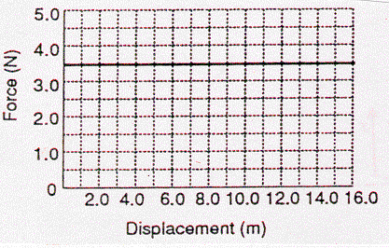 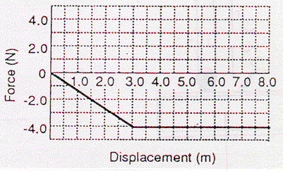

2. The cable of a large crane applies a force of 2.2 x 104 N to a demolition ball as the ball is lifted vertically a distance of 7.6 m. How much work does this force do on the ball? Is this work positive or negative? Explain. (+1.7 x 105 J)

3. Fred is moving into an apartment at the beginning of the school year. Fred weighs 685 N and his belongings weigh 915 N. How much work does the elevator do in lifting Fred and his belongings up five stories (15.2 m)? How much work does the elevator do on Fred on the downward trip? (+2.43 x 104 J, -1.04 x 104 J)

4. The drawing below shows a boat being pulled by two locomotives through a two kilometre canal. The tension in each cable is 5.00 x 103 N and  = 20o. What is the work done on the boat by the locomotives? (1.88 x 107 J)

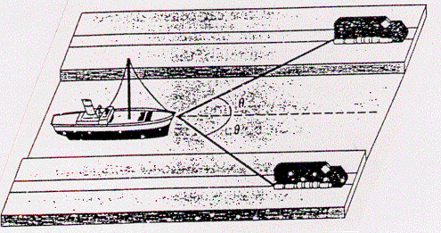

5. A 2.40 x 102 N force, acting at 20o above the surface, is pulling on an 85.8 kg refrigerator across a horizontal floor. The frictional force opposing the motion is 1.67 x 102 N and the refrigerator is moved a distance of 8.00 m. Find the work done by the applied force and the work done by the frictional force.

(1.80 kJ, 1.34 kJ)

6. A 100 kg crate is pulled across a horizontal floor by a force P that makes a 30o angle with the floor. If the frictional force is 196 N, what would be the magnitude of P so that the net work is zero? (226 N)

7. A window washer on a scaffold is hoisting the scaffold up the side of a skyscraper by pulling down on a rope. The combined mass of the window washer and the scaffold is 155 kg. If the scaffold is pulled up at a constant velocity through a distance of 120 m:

a. How much work was done? (1.82 x 105 J)

b. What force must the window washer supply? (507 N)

c. How many meters of rope are required, assuming that the pulleys touch at the top? (360 m)

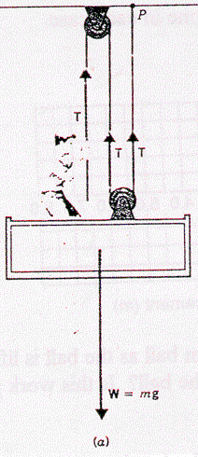 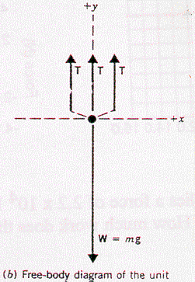

*Kinetic and Potential Energy Problems*

1. A 65.0 kg jogger is running at a speed of 5.30 m/s. What is the jogger’s kinetic energy? (913 J)

2. Relative to the ground, what is the energy of a 55.0 kg person at the top of the Sear's Tower in Chicago, which is 443 m high? (239 kJ)

3. A 75.0 kg skier rides a 2830 m long chair lift to the top of a mountain. The lift makes an angle of 14.6o with the horizontal. What is the change in the skier's potential energy? (525 kJ)

4. A spring is compressed 0.045 m by a 120 N force. What is the spring constant and how much energy is in the spring? (2.67 x 103 N/m, 2.7 J)

5. A spring with a spring constant of 25 N/m is compressed by 9.6 cm. How much energy is in the spring? (0.12 J)

*Power Problems*

1. What is the standard unit of power? Is the unit kWh (kilowatt hour) a unit of force, energy or power? Explain.

2. What is the power output of a machine which applies a force of 2.50 x 104 N for 12.0 s in pulling a block through 60.0 m? (125 kW)

3. A machine has an output power of 10.0 kW. How long would it take for the machine to raise a 5000 kg load through a height of 2.5 m? (12.3 s)

4. Water flows over a section of Niagara Falls at the rate of 1.2 x 106 kg/s and falls 50.0 m. How much power is generated by the falling water? (5.9 x 108 W)

5. A machine operates at a power consumption of 3.5 kW for ten minutes. In the process it produces 500 kJ of waste heat energy. How much net work was done? (1.6 MJ)